Eclipsa Documentation

The software Eclipsa has a pretty straight forward structure

* DAL –DATA ACCESS LAYER
  + All queries between the application and the database happen here.
* TraineeDAL- Has methods to query user creation, edits, and deletion
* WorkoutDAL- Has methods to query equipment creation, edits, and deletion

\*Each method is aptly named.

* BLL- BUISNESS LOGIC LAYER
  + The structures of the files are very close to the Singlton patern as they often return single instances
  + TraineeBLL
    - This contains the logic layer. This will be used in the backend of your ASP.NET webpage to link to the DATA ACCESS LAYER. This particular file is for USERS.
  + WorkoutBLL
    - This contains the logic layer. This will be used in the backend of your ASP.NET webpage to link to the DATA ACCESS LAYER. This particular file is for EQUIPMENT.
* Models – DATA MODELS- This allows the querys to have a data type to move when querying.
  + Trainee – This is the USER data model
  + Workout – This is the EQUIPMENT data model

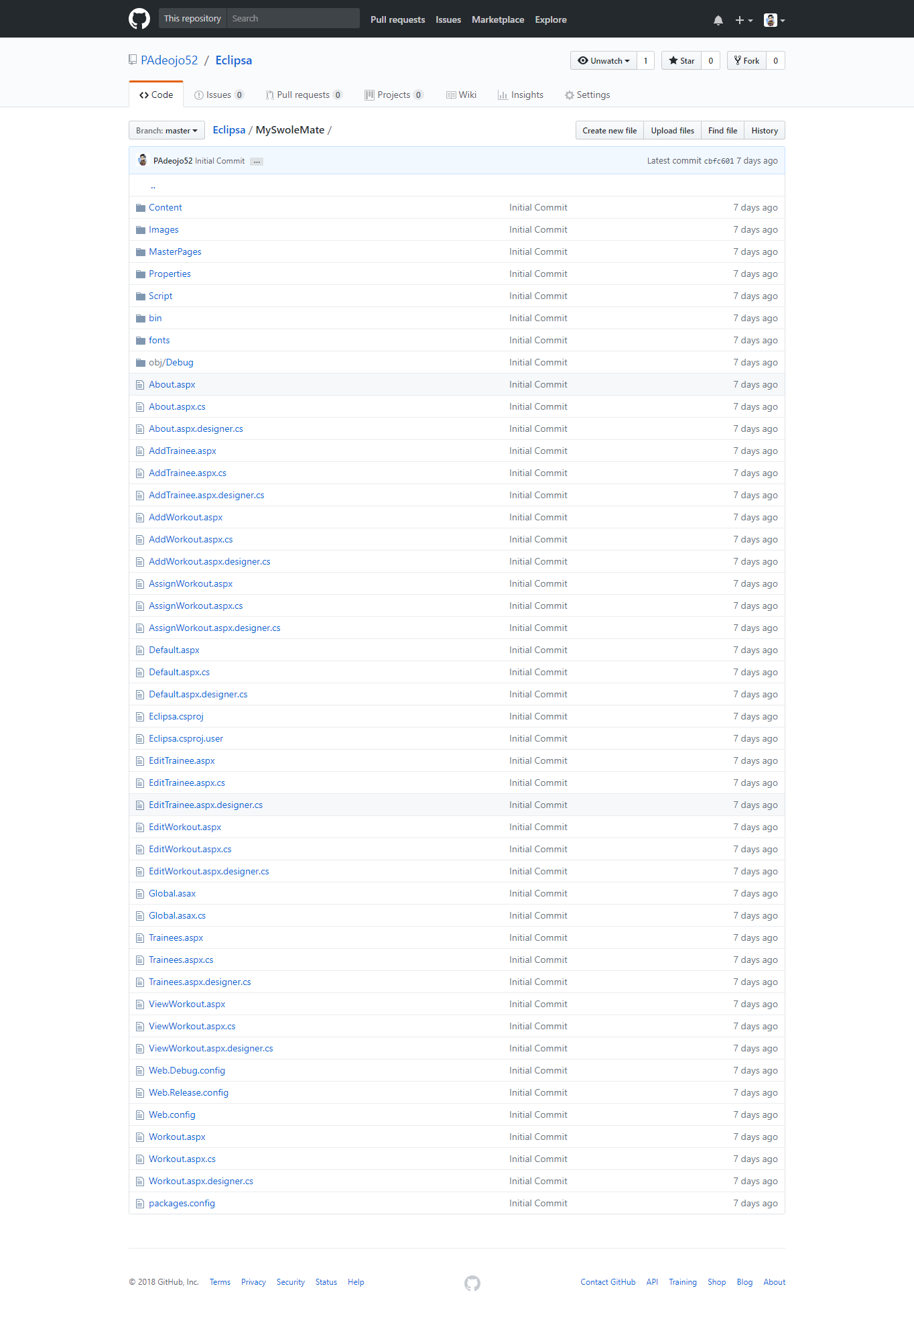

The picture above shows all the webpages on the site. Each webpage has a CS file associated with it that works the same way a JS file works with HTML. C# can go directly into the ASP HTML however it is neater to keep the backend CS file.

Each page is aptly named so you know what each page does.